1. **Create a Lambda function which get triggered from a SNS and lists all the running instances.**

*Code for counting number of instances and saving it to S3*

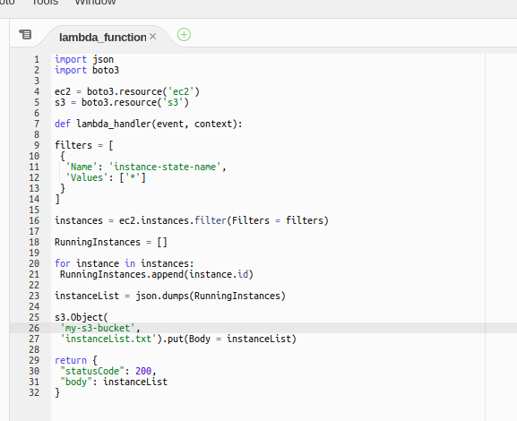

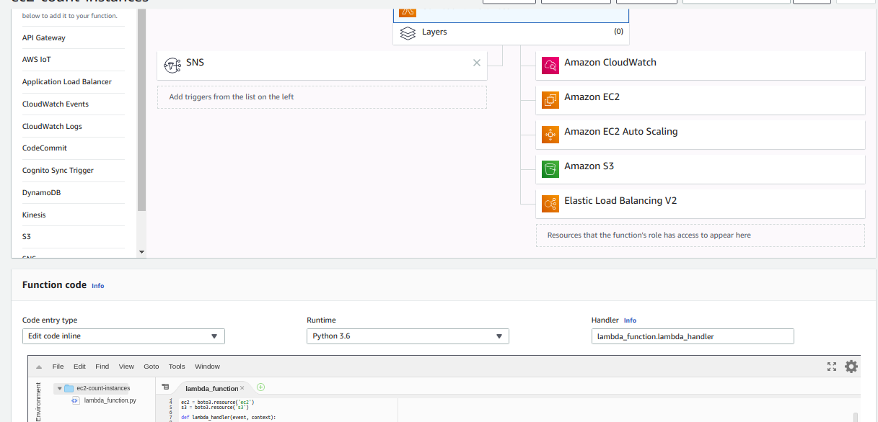

*SNS Subscription for AWS Lambda*

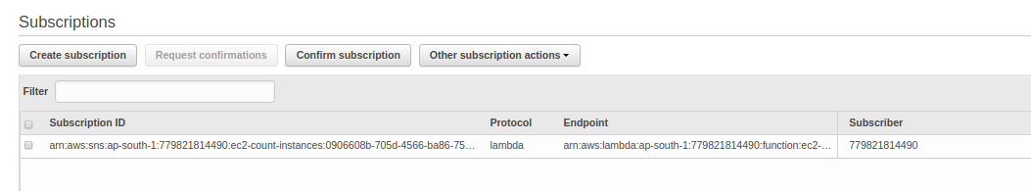

*Lambda Trigger*

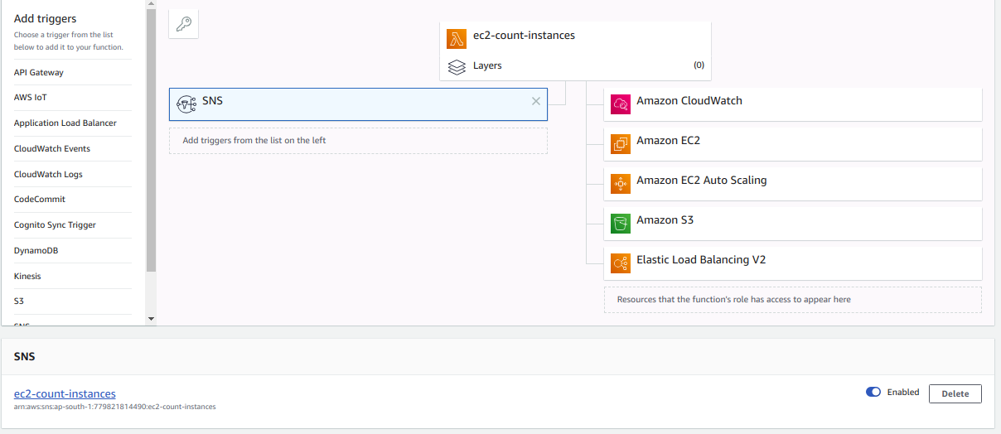

1. **Create a Lambda function which gets invoked whenever a file is added to a s3 bucket and prints the list of all the files present in that bucket.**

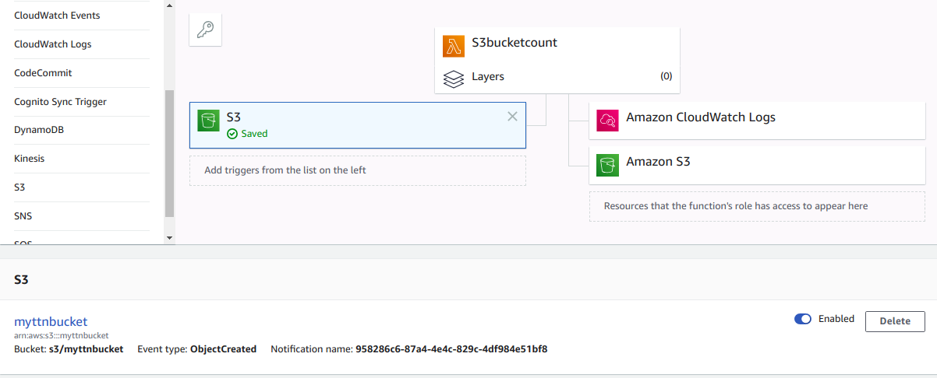

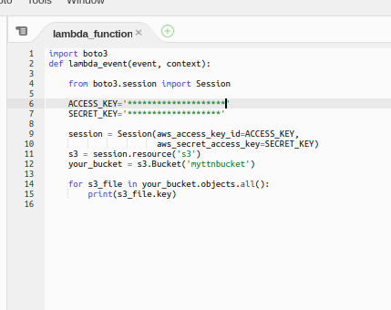

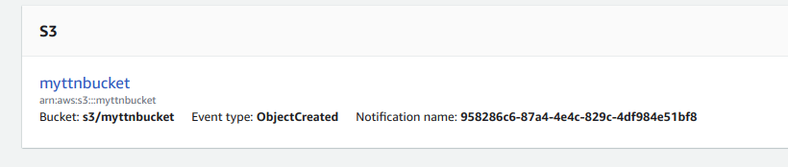

1. **Create a Lambda functions which gets triggered daily and takes the AMI of a particular EC2 instance.**

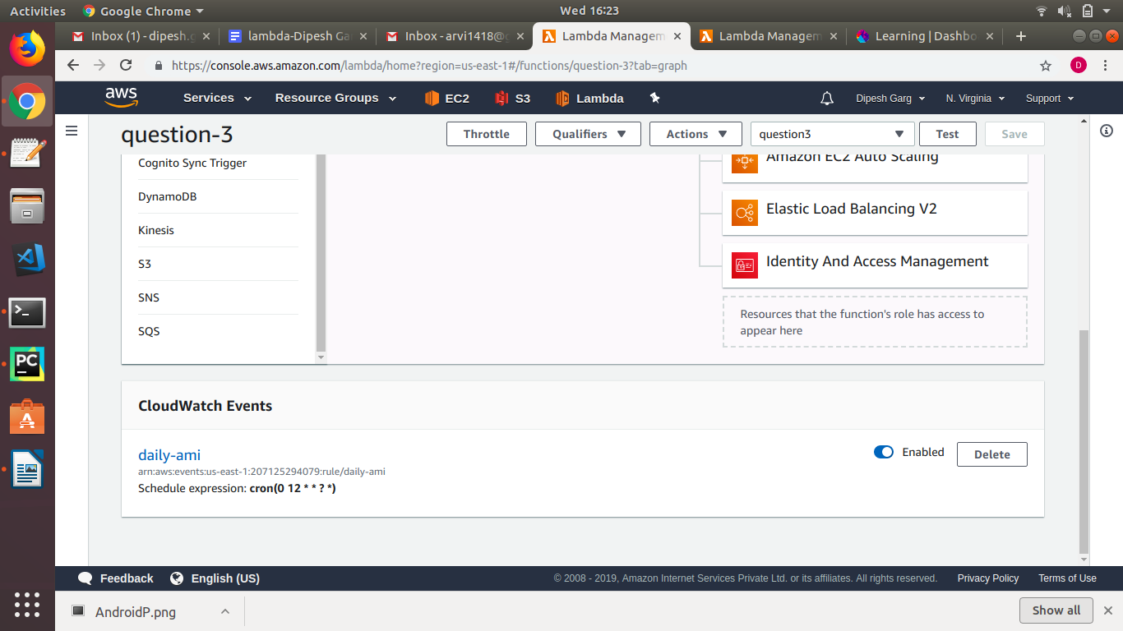

import json

import boto3

def lambda_handler(event, context):

access_key='xxxxxxxxxxxxxxxxx'

secret_key='xxxxxxxxxxxxxxx'

ec2 = boto3.client('ec2')

ec2.create_image(InstanceId="i-0afda09f6dd6cef20",Name="ec2")

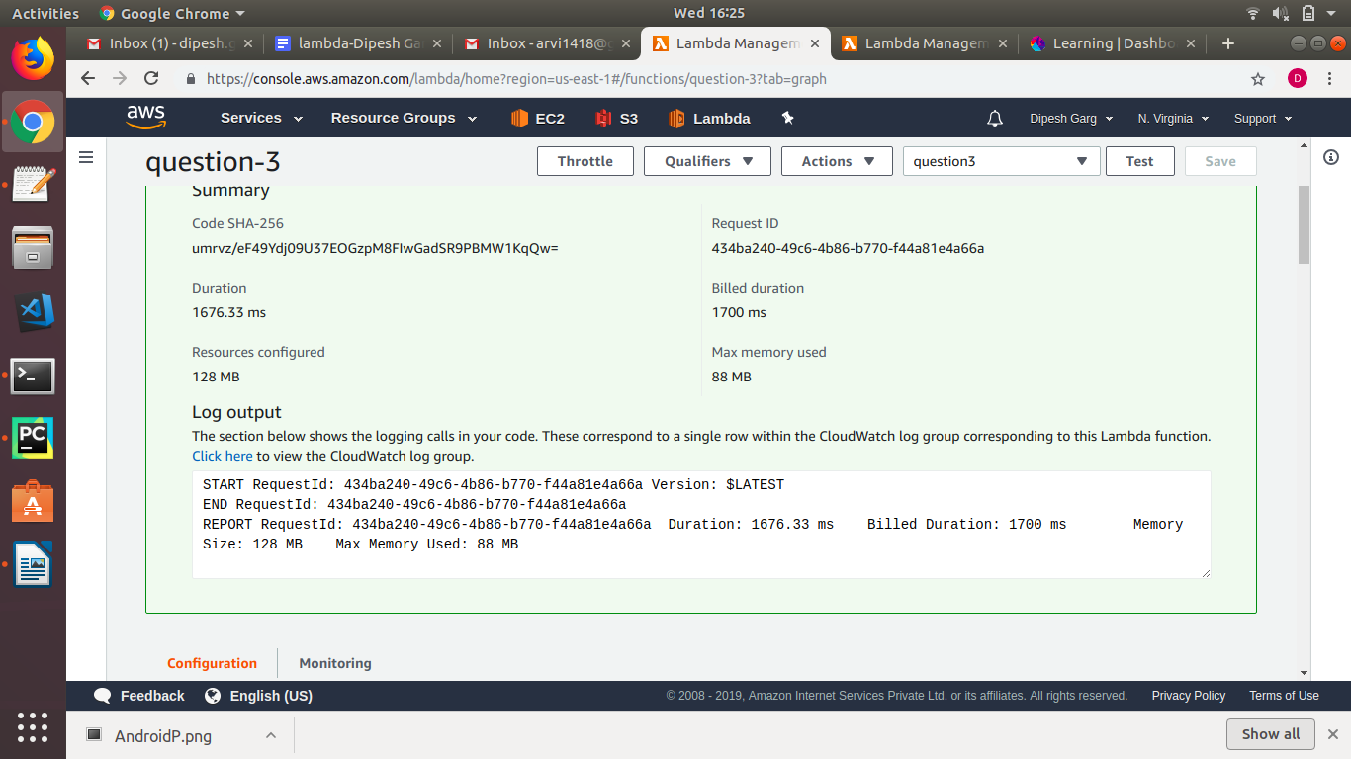

1. **Create a Lambda function which will login to a EC2 instance and prints all the running services. (Use python’s paramiko module to do SSH. Also, launch lambda in a VPC).**

Doubt in this question